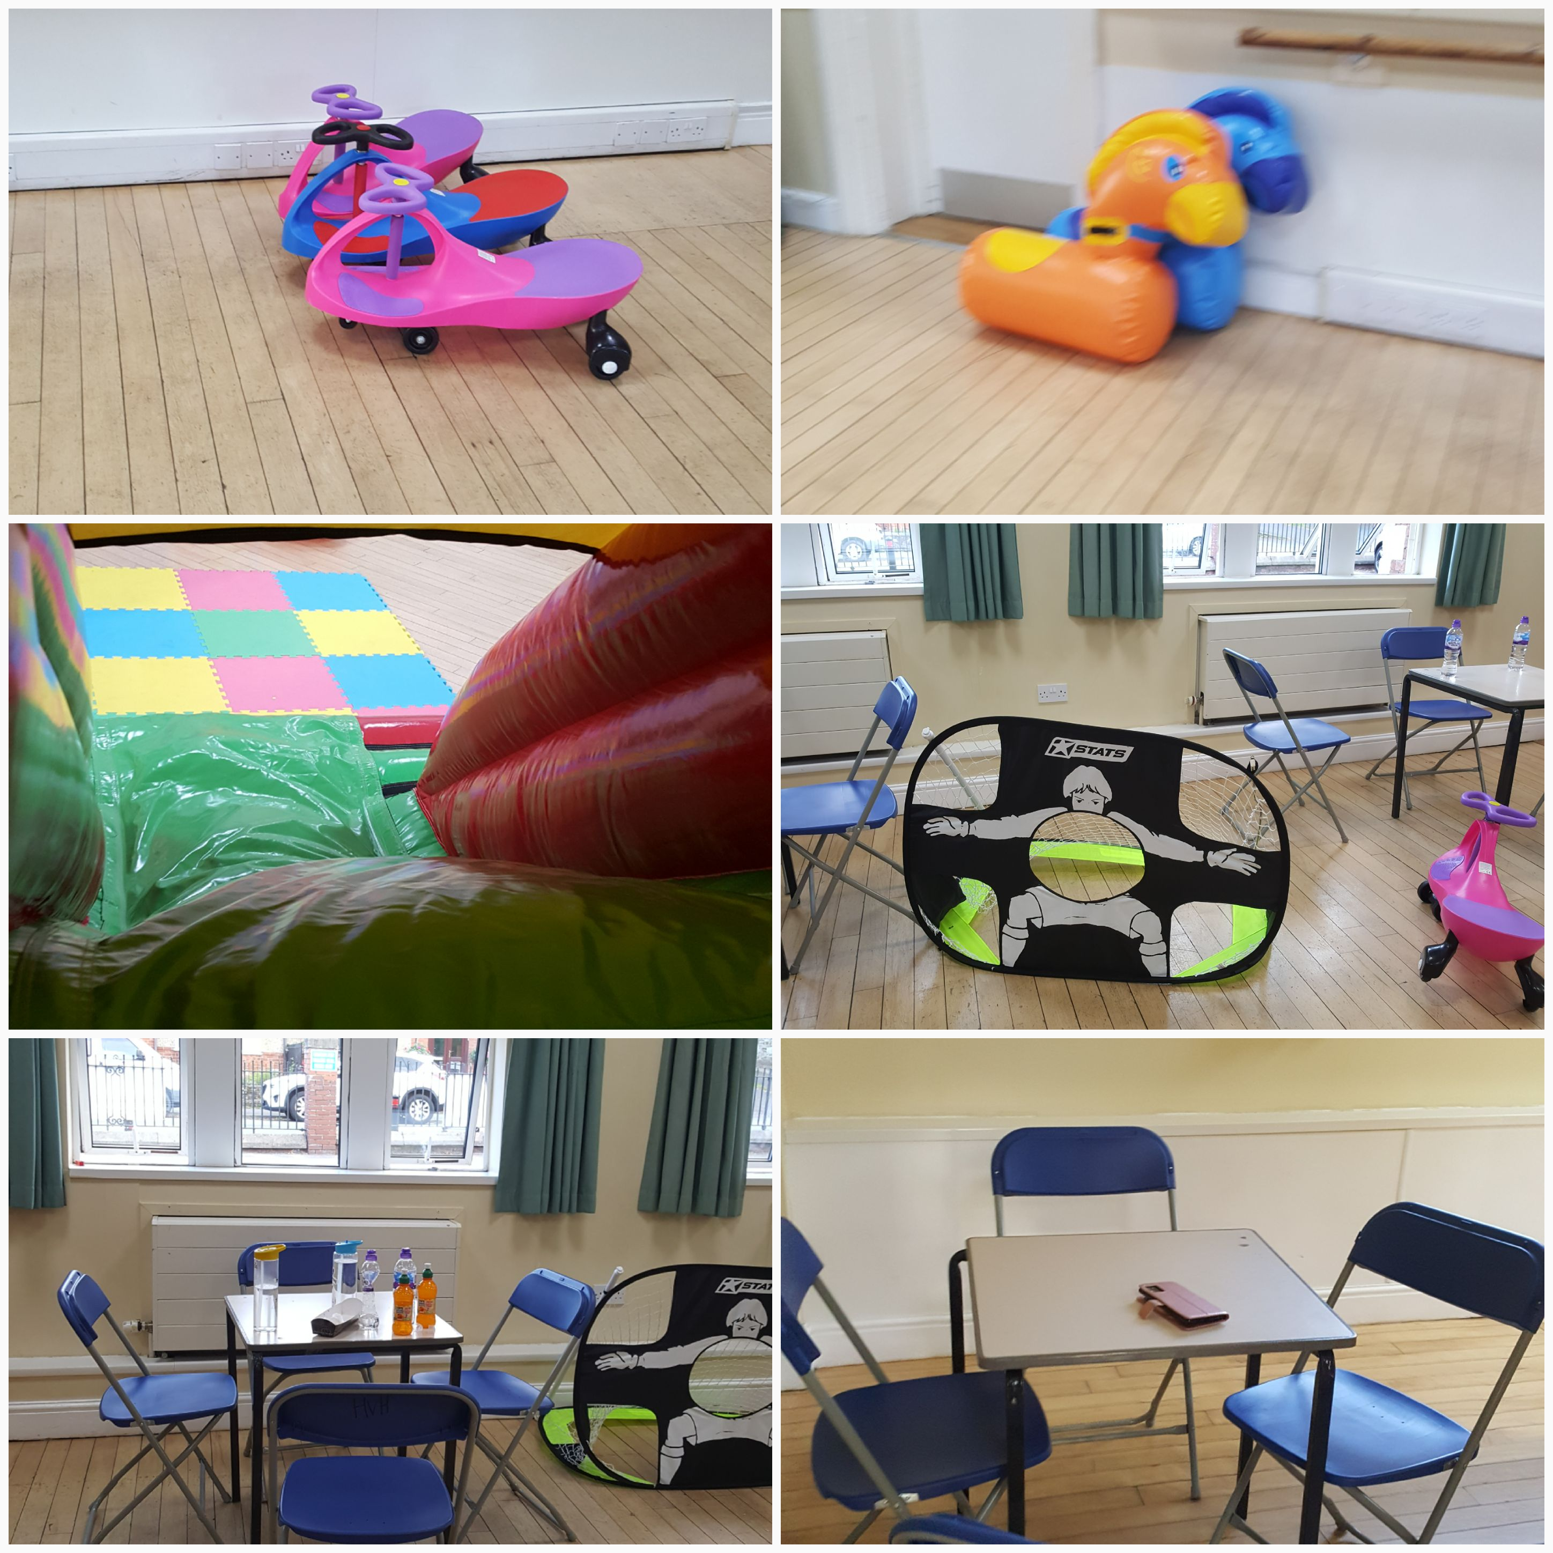  SPACES AVAILABLE FROM SEPTEMBER, BOOK YOUR CHILDREN NOW  My-STS WONDERLAND DAYCARE @ BLACKY mORE COMMUNITY CENTRE NN4 0WP  Out-of-School Daycare setting, super-fun, engaging, creative, educational and inclusive.  We are open all year round to all children.  Please contact us for more details.  OFSTED REGISTERED, we accept childcare tax credit, childcare vouchers and others  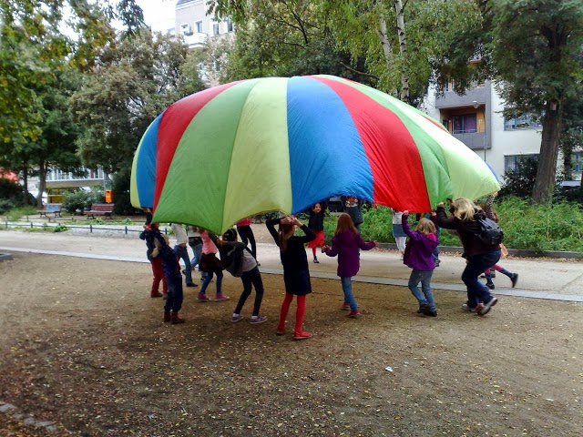  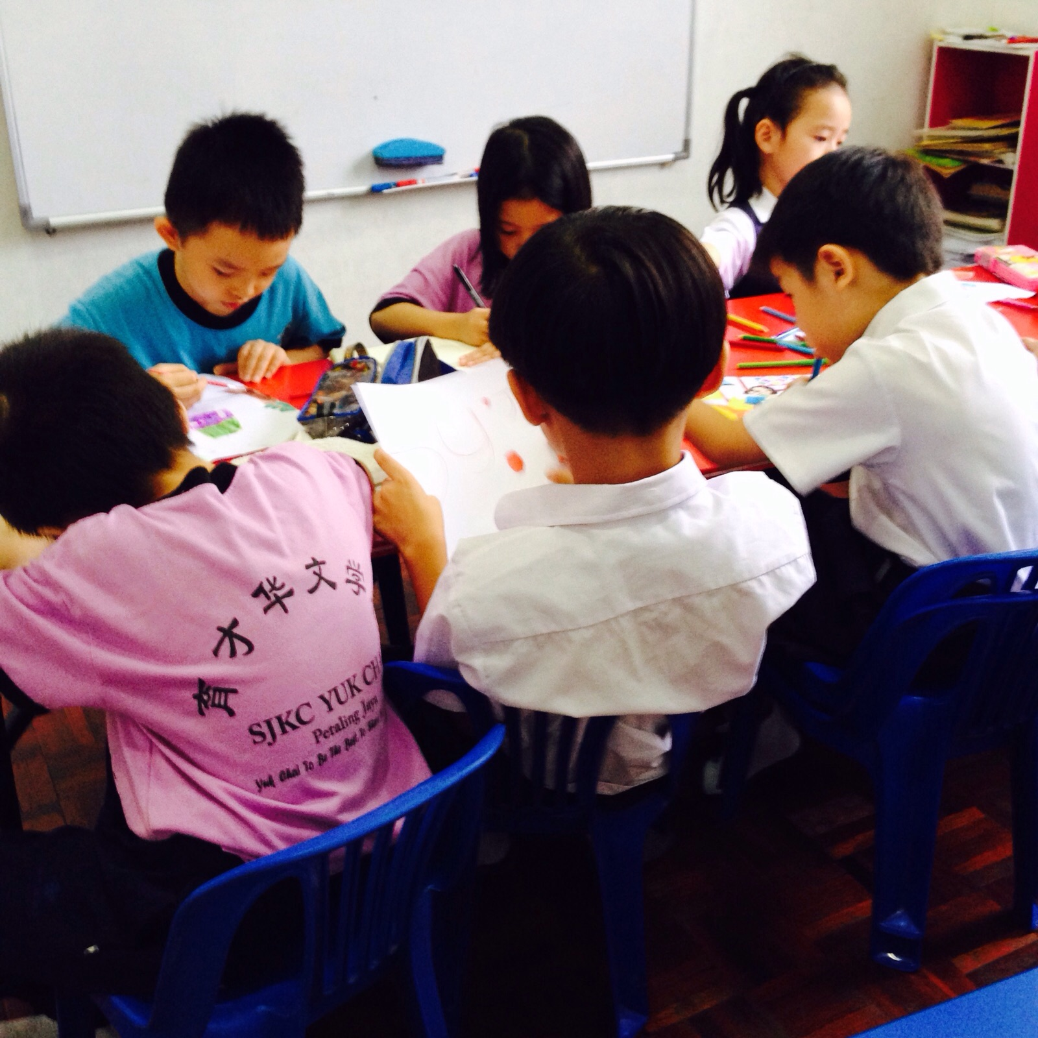 | Open to children in preschool, primary and secondary school.  ──── Out-of-School Clubs:  Before-School /Breakfast Club 7.15 – 9.00 & school drop-off  After-School Club 15.00 -18.00 & school pick-up  Holiday Club 7.30 - 17.30  All clubs include hot meal, drinks, games, play-activities, homework support, and more….  contact us  07404361248  mystswonderland@gmail.com  Facebook.com/mystswonderland  mystswonderland.com

